**Generate sampled sinusoidal, square and sawtooth voltage signal of a given properties (offset, amplitude, signal frequency, initial phase, sample frequency, length of the signal). All of these parameters can be set at the begin of the matlab script code. Create MS Word document (doc, docx), insert figures of those signals as well as text source code in MATLAB or Mathematica and finaly insert your individual comments with conclusion.**

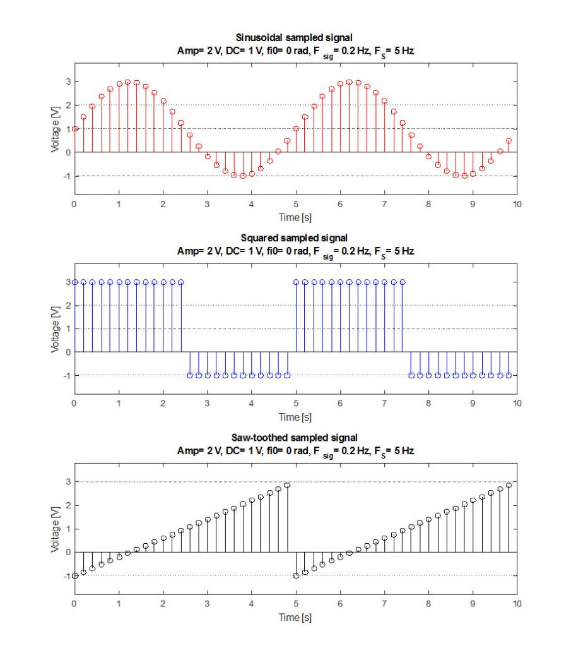

1. **Sinusoidal sampe signal**

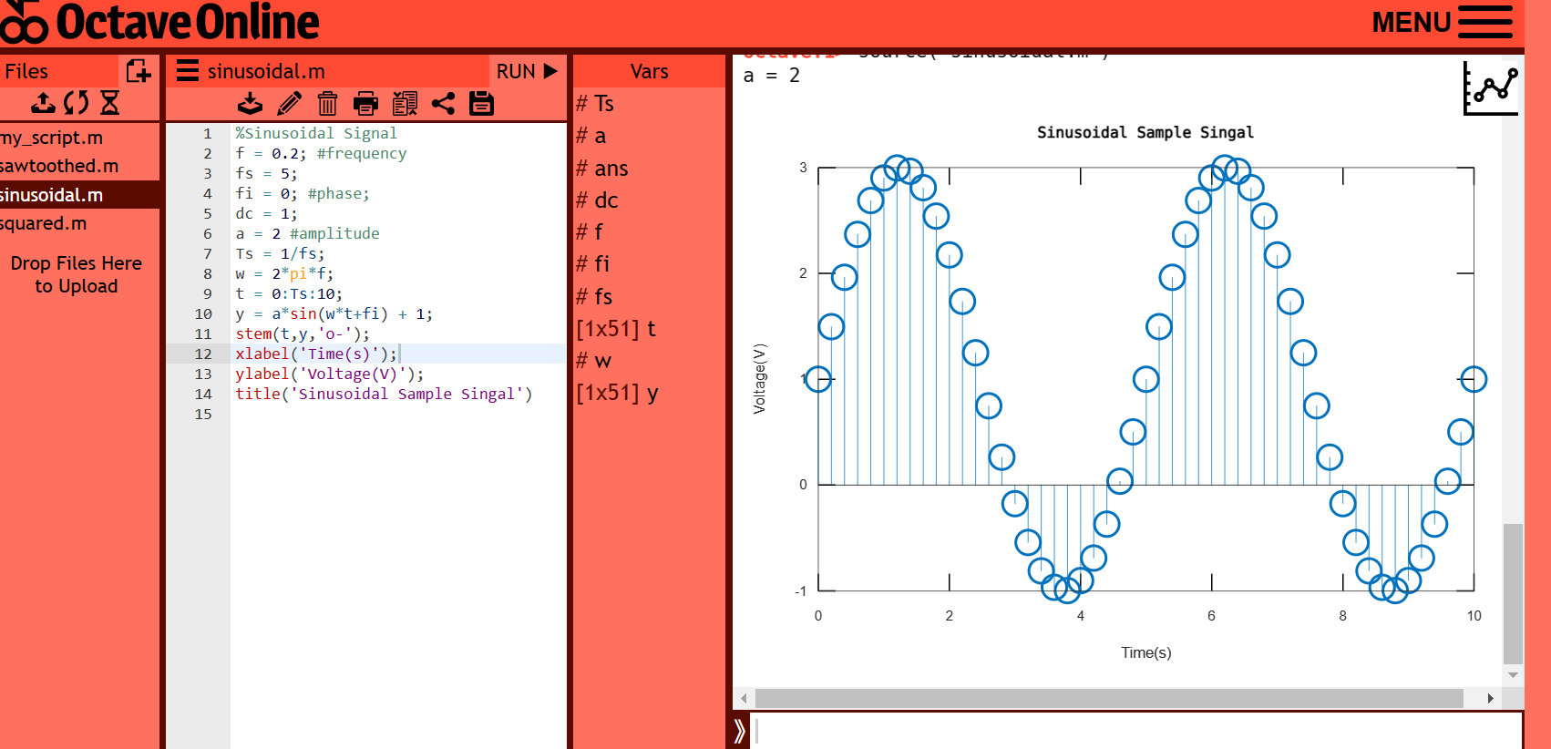

**Source code for octave online**

%Sinusoidal Signal

f = 0.2; #frequency

fs = 5;

fi = 0; #phase;

dc = 1;

a = 2 #amplitude

Ts = 1/fs;

w = 2*pi*f;

t = 0:Ts:10;

y = a*sin(w*t+fi) + 1;

stem(t,y,'o-');

xlabel('Time(s)');

ylabel('Voltage(V)');

title('Sinusoidal Sample Singal')

Comment: The code generates a sinusoidal signal with frequency, phase, amplitude and DC offset specified by the variables f, fi, a and dc, respectively. The signal is sampled at a frequency of fs Hz and a time vector t is generated with a sampling period of Ts. The sinusoidal signal is then calculated using the sin function and the time vector t, and is plotted using a stem plot with time on the x-axis and voltage on the y-axis. The plot is labeled with the x-axis label "Time(s)", the y-axis label "Voltage(V)" and the title "Sinusoidal Sample Signal".

1. **Square sample signal**

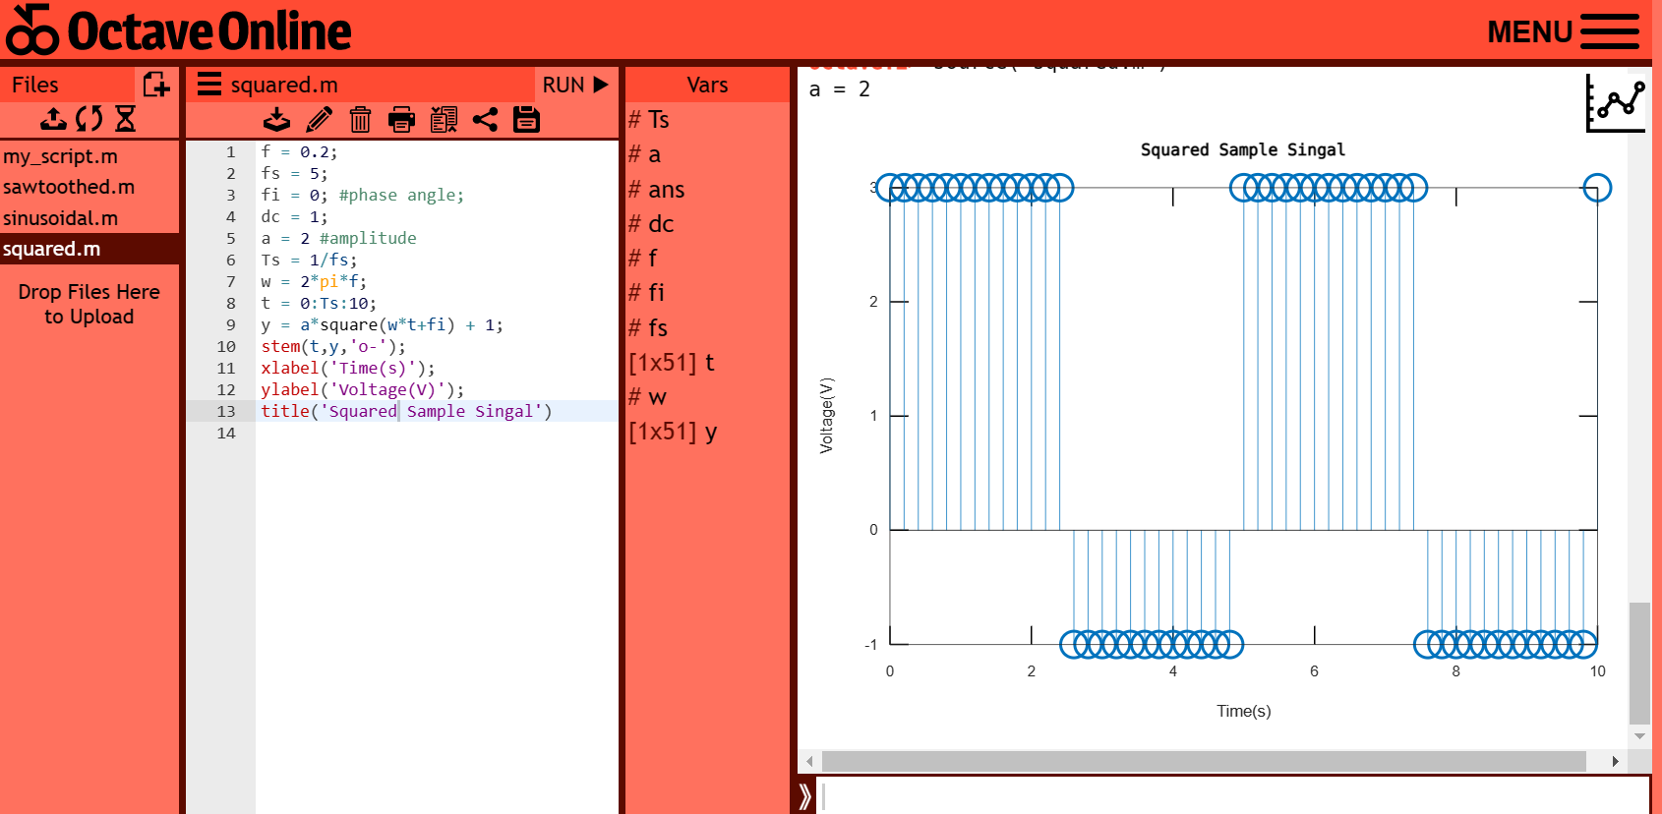

**Source Code for octave online**

f = 0.2;

fs = 5;

fi = 0; #phase angle;

dc = 1;

a = 2 #amplitude

Ts = 1/fs;

w = 2*pi*f;

t = 0:Ts:10;

y = a*square(w*t+fi) + 1;

stem(t,y,'o-');

xlabel('Time(s)');

ylabel('Voltage(V)');

title('Squared Sample Singal')

Comment: The code generates a square wave signal with frequency, phase angle, amplitude and DC offset specified by the variables f, fi, a and dc, respectively. The signal is sampled at a frequency of fs Hz and a time vector t is generated with a sampling period of Ts. The square wave signal is then calculated using the square function and the time vector t, and is plotted using a stem plot with time on the x-axis and voltage on the y-axis. The plot is labeled with the x-axis label "Time(s)", the y-axis label "Voltage(V)" and the title "Squared Sample Signal".

1. **Sawtooth**

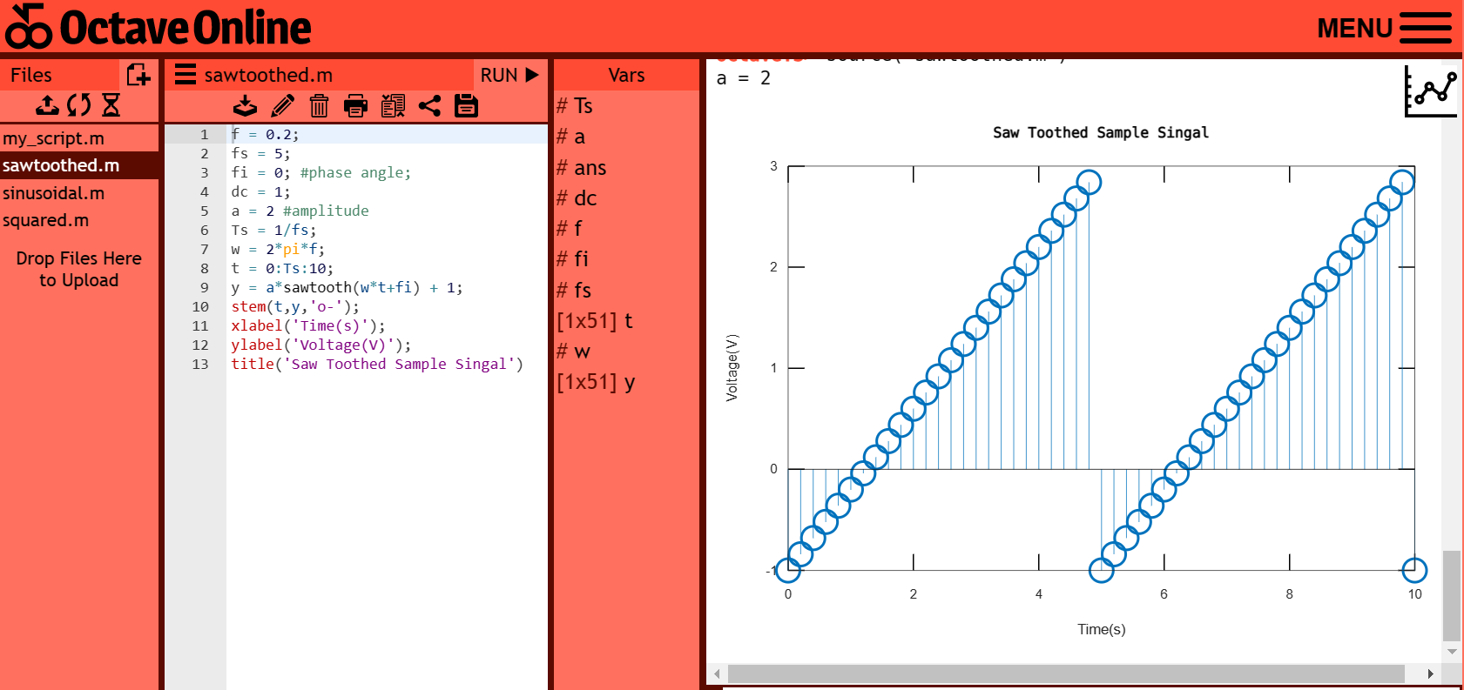

**Source Code for octave online**

f = 0.2;

fs = 5;

fi = 0; #phase angle;

dc = 1;

a = 2 #amplitude

Ts = 1/fs;

w = 2*pi*f;

t = 0:Ts:10;

y = a*sawtooth(w*t+fi) + 1;

stem(t,y,'o-');

xlabel('Time(s)');

ylabel('Voltage(V)');

title('Saw Toothed Sample Singal')

Comment: The code generates a sawtooth wave signal with frequency, phase angle, amplitude and DC offset specified by the variables f, fi, a and dc, respectively. The signal is sampled at a frequency of fs Hz and a time vector t is generated with a sampling period of Ts. The sawtooth wave signal is then calculated using the sawtooth function and the time vector t, and is plotted using a stem plot with time on the x-axis and voltage on the y-axis. The plot is labeled with the x-axis label "Time(s)", the y-axis label "Voltage(V)" and the title "Saw Toothed Sample Signal".